**Lab 7: Android FrameLayout**

# **Introduction**

FrameLayout is made to enclose a portion of the screen so that just one thing can be shown there. Since it can be challenging to organise many child views in a way that is scalable to different screen sizes without the children overlapping one another, FrameLayout should often only be used to store a single child view.

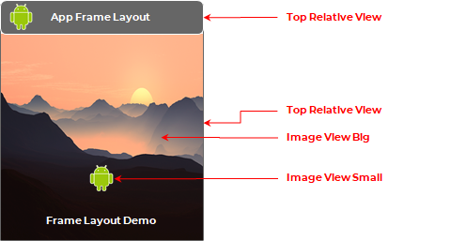

**Let’s get Started**

This exercise will take you through simple steps to show how to create your own Android application using Frame layout.

**Step 1: Create a New Project in Android Studio as shown below**

**Step 2: Select Empty Activity as shown below**

**Step 3: Provide a Project Name as shown below**

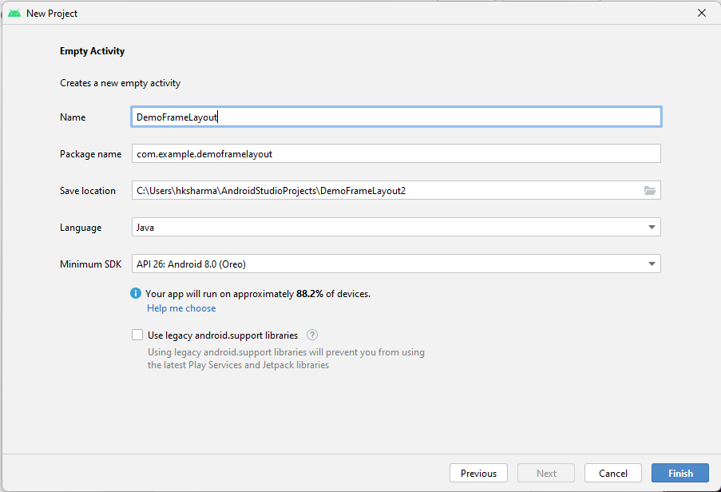

**Step 4: Update MainActivity.java as per the code given below**

**package** com.example.demoframelayout;  
**import** androidx.appcompat.app.AppCompatActivity;  
**import** android.os.Bundle;  
**public class** MainActivity **extends** AppCompatActivity {  
  
 @Override  
 **protected void** onCreate(Bundle savedInstanceState) {  
 **super**.onCreate(savedInstanceState);  
 setContentView(R.layout.***activity_main***);  
 }  
}

**Step 5: Update activity_main.xml as per the code given below**

*<?***xml version="1.0" encoding="utf-8"***?>*<**FrameLayout  
 xmlns:android="http://schemas.android.com/apk/res/android"  
 xmlns:app="http://schemas.android.com/apk/res-auto"  
 xmlns:tools="http://schemas.android.com/tools"  
 android:layout_width="match_parent"  
 android:layout_height="match_parent"  
 tools:context=".MainActivity"**>  
<**ImageView  
 android:layout_width="match_parent"  
 android:layout_height="match_parent"  
 android:src="@drawable/bg1"  
 android:scaleType="fitXY"** />  
 <**TextView  
 android:layout_width="match_parent"  
 android:layout_height="wrap_content"  
 android:text="@string/text1"  
 android:layout_gravity="center"  
 android:layout_marginHorizontal="100dp"  
 android:textSize="30dp"  
 android:textColor="#DF1919"  
 android:textStyle="bold"** />   
</**FrameLayout**>

**Step 6: Check Output on Android Emulator and it should look like as given below**

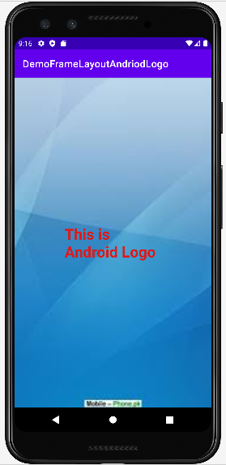

**Voila!!** We have successfully completed this lab.